Unit 5 Assignment 2
Trevor Huddleston
CS352 Data Structures
11/5/2025
Professor Li
- Describe the state of your project, what works and what doesn’t.
We discussed in class how the program would not run in the class environment you had created in GitHub, so you advised me to just create a version of my repository and send you a link so you could access the program and test the files. That link is here: https://github.com/OhshyBear/Unit-5-assignment-2-OhshyBear-2
- Describe how you tested your program
In each design step, I wrote simple tests to verify that my code up to that point was working. Initially, I had an issue with the boolean method for high temperatures because it was measuring low-to-high, but the instructions asked for the highest temperature first. After correcting this, all lists sorted correctly, and I verified the results using the toString() method and the boolean checks.
- Show your timing data and write a paragraph on the benefits/drawbacks of writing a custom sort routine.
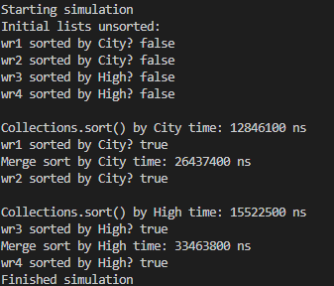
The main benefit is that it gives full control over how data is sorted, allowing for descending sorts or other custom rules that may not be as simple with built-in methods. It also reinforces understanding of recursion and algorithmic thinking. The main drawback is that it is more time-consuming and error-prone to implement compared to using Collections.sort(), which is highly optimized and requires far less code. In practical applications, built-in sort methods are generally faster and simpler, but implementing a custom sort is a valuable learning exercise.

- In a sentence or two, what did you learn?
I learned how to read data from a file into a linked list, implement both built-in and custom sorting methods, and verify that the data is correctly sorted. I also learned how to measure execution time to compare different algorithms.
- In a sentence or two, what did you find confusing or would like to see done differently regarding this project?
I was confused by my project not being able to run in the initial environment, which really set me back. I had to rely on AI more than I would have liked for this project to get it turned in on time.
- In a sentence or two, if you had another hour or two, what would you like to add to the project or how would you do things differently?
I would slow down and not turn to AI for solutions as much. I would like to try to troubleshoot on my own more, but I had to hurry to ensure everything was implemented correctly and submitted on time.

